# **UML Sequence Diagrams**

Player Sequence Diagram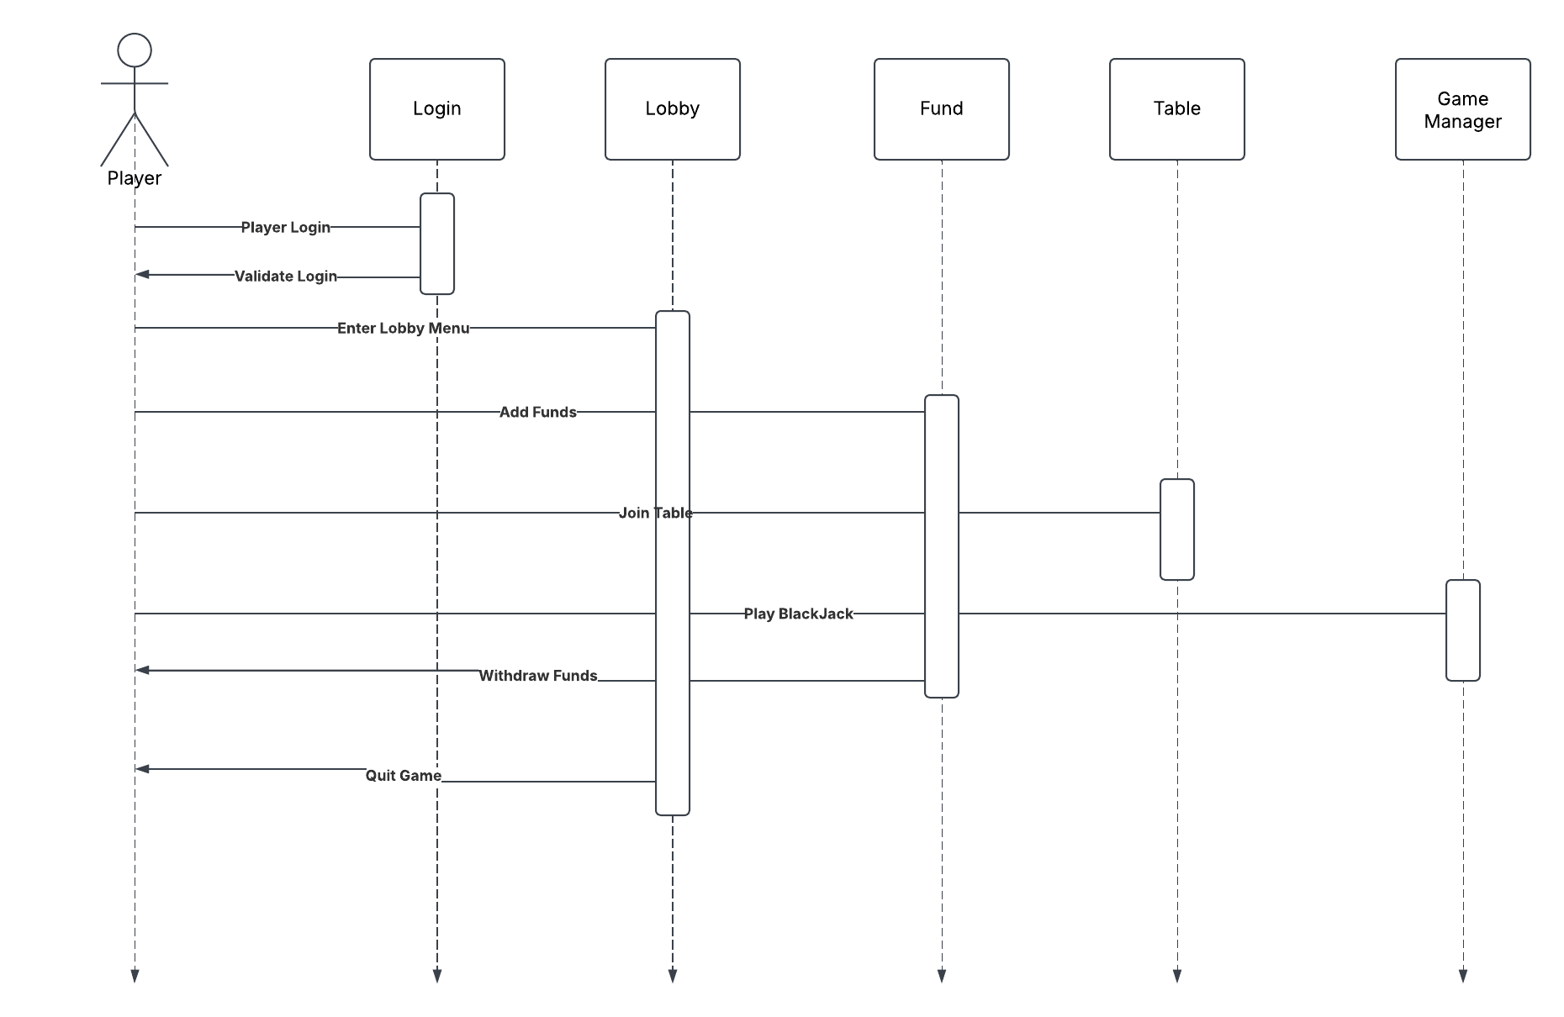

Dealer Sequence Diagram

